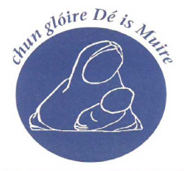
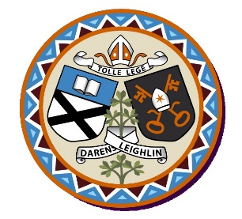
Scoil Mhuire Junior
Annual Admission Notice
in respect of admissions to the 2024/2025 school year

Admission Policy and Application Form
A copy of the school’s Admission Policy and the Application Form for Admission for Scoil Mhuire Junior is available as follows:
To download at: www.scmj.ie
On request: By emailing office@scmj.ie or writing to Scoil Mhuire Junior, Ballymany, Newbridge, Co Kildare.
Part 1 - Admissions to the 2024/’25 school year
Application and Decision Dates for admission to 2024/’25
The following are the dates applicable for admission to Junior Infants

The school will commence accepting applications for admission on | 08/01/2024
The school shall cease accepting applications for admission on | 29/01/2024
The date by which applicants will be notified of the decision on their application is | 13/02/2024
The period within which applicants must confirm acceptance of an offer of admission is | 27/02/2024

Note: Any applications submitted after this date are welcome.
The school will consider and issue decisions on late applications in accordance with the school’s Admission Policy.
Failure to accept an offer within the prescribed period above may result in the offer being withdrawn
Special Class Application and Decision Dates for admission to Scoil Mhuire Junior
The following are the dates applicable for admission to the school’s Special Class which caters for children with Autistic Spectrum Disorder and the report from a recognised medical expert specifying that the child’s needs are best met in an ASD Unit.
The school will commence accepting applications for admission to the special class on | 08/01/2024
The school shall cease accepting applications for admission to the special class on | 29/01/2024
The date by which applicants will be notified of the decision on their application for admission to the special class is | 13/02/2024
The period within which applicants must confirm acceptance of an offer of admission is | 27/02/2024
*Failure to accept an offer within the prescribed period above may result in the offer being withdrawn
Number of Places being made Available in 2024/2025

The number of places being made available in junior infants | 96
The number of places being made available in the special class* catering for children with Autistic Spectrum Disorder in the special class is | 1

Part 2 - Admissions to the 2023/2024 School Year
In respect of the 2023/2024 school year, the total number of applications for admission received by the school was 65.
Information regarding the admission process for the Intake Group for our ASD Class for the 2023/2024 school year

Breakdown of places allocated for the 23/’224school year:
Number of places available: | 1
Number of applications received: | 37
Number of Offers made and accepted | 1  Criteria 2: Siblings of children enrolled in Scoil Mhuire: 1 Place offered, 1 place accepted.
Total number of offers made | 1
Number of names placed on waiting list for the school year concerned. | 36

